1. Question

TRUE OR FALSE  
After users are enrolled in MFA they must configure a  second authentication factor the next time they sign in

* +  FALSE
  +  TRUE

2. Question

You are a Microsoft 365 administrator. You need to implement the appropriate features for this scenario. What should you implement?  
“Secure members of the Global Administrators Group by using dynamic risk profiles”

* +  Microsoft Azure AD Conditional Access
  +  Microsoft Azure AD Identity Protection
  +  Microsoft Azure AD Privileged Identity Management

3. Question

TRUE OR FALSE  
Compliance Manager performs assessment against your entire Microsoft 365 environment and evaluates both Microsoft and Customer controls.

* +  Yes
  +  No

4. Question

A company purchases Microsoft 365 E5.

You need to determine which security features you should implement.

Which features should you implement” To identify sensitive data and create policies that help prevent users from accidentally or intentionally sharing the data?

* +  Customer Lockbox
  +  Data Loss Prevention
  +  Microsoft Office 365 Advanced Threat Protection
  +  Microsoft Office 365 secure score

5. Question

You need to reduce the amount of time that the IT team spends on user support. What are the three possible ways to achieve this goal?  
Note that each correct answer presents a complete solution

* +  Deploy Microsoft my analytics to devices
  +  Enable Microsoft Office 365 customer lockbox
  +  Deploy Microsoft Office 365 Enterprise to all client devices
  +  Use windows autopilot to deploy devices
  +  Upgrade all client devices to Windows 10

6. Question

You are the Microsoft 365 administrator for a company.

Your company plans to open a new office in the United Kingdom.

You need to provide penetration tests and security assessment reports for the new office.

Where can you locate the required reports?

* +  Data Loss Prevention page of the Security and Compliance portal
  +  Compliance Manager page of the Services Trust portal
  +  Data Governance page of the Security and Compliance portal
  +  Regional Compliance page of the Services Trust portal

7. Question

You need to configure a data governance solution for your company. You know the complete solution must meet the following requirements:

-> Classify documents

-> Ensure that classifications are enforced

-> Delete documents that are no longer used

Which actions should you perform to perform 2nd step i.e. Ensure that classifications are enforced?

* +  Configure Microsoft Outlook mail tips
  +  Configure document approval
  +  Apply supervision policies

8. Question

You need to configure a data governance solution for your company. You know the complete solution must meet the following requirements:

-> Classify documents

-> Ensure that classifications are enforced

-> Delete documents that are no longer used

Which actions should you perform to perform 1st step I.e. Classify documents?

* +  Apply  Microsoft SharePoint permissions
  +  Publish Labels
  +  Define File and Folder Structures

9. Question

You are the Microsoft 365 administrator for a company.

You need to identify available cloud security features.

Match this feature to the correct description.  
Block users from accessing cloud apps from certain devices.

* +  Microsoft Azure AD Conditional Access
  +  Cloud Discovery Dashboard
  +  Microsoft Azure Security Centre
  +  Microsoft Azure Information Protection

10. Question

You are the Microsoft 365 administrator for a company.

You need to identify available cloud security features.

Match this feature to the correct description.  
Classify and label e-mails and documents in the organization.

* +  Microsoft Azure Security Centre
  +  Microsoft Azure AD Conditional Access
  +  Cloud Discovery Dashboard
  +  Microsoft Azure Information Protection

11. Question

A company is moving to Microsoft Azure. Some applications cannot be moved. You need to identify which applications will remain in a hybrid environment after the migration. Which applications will remain in a hybrid environment?

* +  legacy applications that use a message-based interface
  +  applications that use a USB-token device to control access
  +  a new server that runs several line-of-business applications
  +  applications that manage sensitive information

12. Question

A company plans to migrate to Microsoft 365.

You need to advise the company about how Microsoft provides protection in a multitenancy environment.

What are the three ways that Microsoft provides protection? Each correct answer presents part of the solution. (Choose three.)

NOTE: Each correct selection is worth one point.

* +  Customer content at rest is encrypted on the server by using BitLocker.
  +  Customer content in transit is encrypted on the server by using transport-layer security (TLS).
  +  Logical isolation of customer content within each tenant for Microsoft 365 services is achieved through Azure Active Directory authorization and role-based access control.
  +  Mailbox databases in Microsoft Exchange Online contain only mailboxes from a single tenant.
  +  Microsoft Azure AD provides authorization and role-based access control at the transport layer
  +  Mailbox databases in Microsoft Exchange Online contain mailboxes from multiple tenants.

13. Question

A company purchases Microsoft 365 E5.

You need to determine which security features you should implement.

Which features should you implement for “Providing recommendations to reduce risk”?

* +  Microsoft Office 365 secure score
  +  Customer Lockbox
  +  Data loss prevention
  +  Microsoft 365 Advanced Threat Protection

14. Question

True or False  
To enable or disable targeted releases in an organization, select each user who should receive early access to features and functionality from a list.

* +  TRUE
  +  FALSE

15. Question

TRUE OR FALSE  
Cloud solution providers can bill customers for Microsoft 365 licenses on an annual basis.

* +  Yes
  +  No

16. Question

A company deploys Microsoft Azure AD. You enable multi-factor authentication. You need to inform users about the multi-factor authentication methods that they can use. Which of the following methods is NOT a valid multi-factor authentication method in Microsoft 365?

* +  Insert a small card into a desktop computer and provide a PIN code when prompted
  +  Receive an automated call on the desk phone that includes a verification code
  +  Receive an SMS text message that includes a verification code
  +  Receive a call on a mobile phone and select the pound sign (#) when prompted

17. Question

A company deploys Exchange Online and SharePoint Online.

You must audit and assessment report for the Microsoft 365 cloud services that the company uses.

You need to provide the required documents.

Which Microsoft site should you use to obtain this information?

* +  Compliance Manager
  +  Azure portal
  +  Service Trust Portal
  +  Office 365 Security and Compliance Center

18. Question

An organization is considering migrating some of its resources to the cloud. The company does not plan to deploy Microsoft AzureExpressRoute or site-to-site VPNs. You need to identify if this workload can migrate to the cloud by choosing the best answer.  
” A legacy application that requires connectivity to on-premises data store”

* +  Remain On-premise
  +  Migrate to Cloud

19. Question

An organization is considering migrating some of its resources to the cloud. The company does not plan to deploy Microsoft AzureExpressRoute or site-to-site VPNs. You need to identify if this workload can migrate to the cloud by choosing the best answer.  
” You need to deploy  a Microsoft SharePoint collaboration site for partners”

* +  Remain On-premise
  +  Migrate to Cloud

20. Question

You are a Microsoft 365 administrator for a company where employees use Microsoft Office 365 Enterprise to create documents. You need to implement document classification and protection by using Microsoft Information protection which  actions should you perform each current each correct answer presents part of his solution And is worth one point

* +  install the Azure information protection client
  +  Install the rights management service client
  +  add on Azure subscription to your Microsoft 365 tenant
  +  create a custom Azure information protection policy with confidential label
  +  enable the default Azure information protection policy an option is installed the rights management service client

21. Question

An organization plans to deploy Microsoft Intune.

For the following statement, select Yes if the statement is true. Otherwise, select No.  
“Microsoft Intune can define where corporate data is stored”

* +  Yes
  +  No

22. Question

An organization is considering migrating some of its resources to the cloud. The company does not plan to deploy Microsoft AzureExpressRoute or site-to-site VPNs. You need to identify if this workload can migrate to the cloud by choosing the best answer.  
” You need to deploy the external-facing website”

* +  Migrate to Cloud
  +  Remain on-premise

23. Question

This question requires that you evaluate the “Italicized”  text to determine if it is correct.

A company needs to protect documents and emails by automatically applying classifications and labels. You must minimize costs.  
You should implement Microsoft Azure Information Protection for Microsoft Office 365.

Review the above “italicized” text. If it makes the statement correct, select No change is needed. If the statement is incorrect, select the answer choice that makes the statement correct.

* +  Azure Information Protection Premium P1
  +  No change needed.
  +  Azure Information Protection Premium P2
  +  Microsoft 365 E3

24. Question

TRUE OR FALSE  
Cloud Service Providers can provide 30 days of trial licenses to customers

* +  No
  +  Yes

25. Question

True or False  
By default, all the Microsoft 365 users are configured for “Targeted Release”

* +  No
  +  Yes

26. Question

You are the Microsoft 365 administrator for a company. You install Microsoft Office 365 Enterprise on five devices. You deactivate the Microsoft Office 365 Enterprise license on one device.  
Which task can you perform on that device?

* +  Start a new document from a template
  +  Leave a comment in a document
  +  Create a document
  +  print a document
  +  Set properties on a document.
  +  Co-author a document.

27. Question

You need to ensure that the process by which users sign in to Microsoft 365 confirms the identity of the user. Which feature should you use?

* +  Advanced Threat Protection (ATP)
  +  mobile application management (MAM)
  +  data loss prevention (DLP) policies
  +  Multi-Factor Authentication (MFA)

28. Question

You need to configure a data governance solution for your company. You know the complete solution must meet the following requirements:

-> Classify documents

-> Ensure that classifications are enforced

-> Delete documents that are no longer used

Which actions should you perform to perform 3rd step i.e. Delete documents that are no longer used

* +  Apply preservation policies
  +  Configure Microsoft SharePoint second-stage Recycle bin
  +  Apply retention policies

29. Question

You are a Microsoft 365 administrator. You need to implement the appropriate features for this scenario. What should you implement?  
“Secure admin roles by requiring approvals”

* +  Microsoft Azure AD Identity Protection
  +  Microsoft Azure AD Domain Services
  +  Microsoft Azure AD Privileged Identity Management

30. Question

You are the Microsoft Office 365 administrator for a company.

You need to perform security and compliance reviews before new updates are distributed to the entire company.

What should you implement?

* +  FastTrack
  +  Microsoft 365 Enterprise Test Lab
  +  standard releases
  +  targeted releases

31. Question

A company purchases Microsoft 365 E5.

You need to determine which security features you should implement.

Which features should you implement for “Control how a Microsoft Support Engineer accesses data during a help session”?

* +  Microsoft Office 365 secure score
  +  Customer Lockbox
  +  Microsoft 365 advanced threat protection
  +  Data Loss prevention

32. Question

You are a Microsoft 365 administrator. You need to implement the appropriate features for this scenario. What should you implement?  
“Restrict access to Microsoft Outlook using a PIN”

* +  Device Configuration Policy
  +  Mobile Application Protection Policy

33. Question

A company deploys Microsoft Intune.

An employee loses a Windows 10 device that contains corporate data.

You need to ensure that the corporate data on the device is secured as quickly as possible.

Which two options can you use?  
To answer, select the appropriate actions in the answer area.  
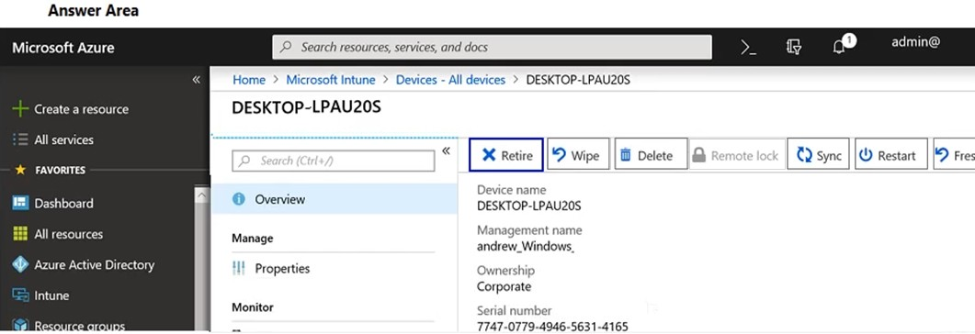

* +  Wipe and Delete
  +  Restart and Delete
  +  Sync and Restart
  +  Retire & Wipe

34. Question

A company plans to migrate to a hybrid cloud infrastructure. You need to determine where to manage the different features after the hybrid deployment is complete.  
“Configure e-mail disclaimers”.

* +  On-Premise only
  +  Both Microsoft 365 and On-Premise
  +  Microsoft 365 only

35. Question

TRUE OR FALSE  
Compliance Managers allow you to take corrective action from within the Service Trust Portal.

* +  No
  +  Yes

36. Question

TRUE OR FALSE  
Cloud Service Providers can only charge customers for licenses that the customers use.

* +  No
  +  Yes

37. Question

TRUE OR FALSE  
Compliance Manager allows you to assign individuals within the organization to be responsible for the control.

* +  No
  +  Yes

38. Question

An organization plans to deploy Microsoft Intune.

For the following statement, select Yes if the statement is true. Otherwise, select No.  
“Data protection can be selectively applied to applications”

* +  Yes
  +  No

39. Question

An organization plans to deploy Microsoft Intune.

For the following statement, select Yes if the statement is true. Otherwise, select No.  
“Once a device is registered with Microsoft Intune data wipe will include users personal data”

* +  Yes
  +  No

40. Question

A company plans to migrate to a hybrid cloud infrastructure. You need to determine where to manage the different features after the hybrid deployment is complete.  
“Set frequency of Microsoft 365 Updates”.

* +  Both On-Premise and Microsoft 365
  +  On-Premise Only
  +  Microsoft 365 Only

41. Question

A company purchases Microsoft 365 E5.

You need to determine which security features you should implement.

Which features should you implement for “Protect against malware, viruses and malicious URLS”?

* +  Customer Lockbox
  +  Data loss prevention
  +  Microsoft Office 365 secure score
  +  Microsoft Office 365 advanced threat protection

42. Question

A company is a Microsoft 365 reseller. The company does not provide managed services or direct customer support. You need to provide licenses for customers and earn commissions for each license sold. What should you do?

* +  Buy licenses for customers by using the Microsoft admin portal.
  +  Buy licenses for customers from a Microsoft Authorized distributor.
  +  Sign up as a Cloud Solution Provider indirect reseller
  +  Sign up as a Cloud Solution Provider direct reseller.

43. Question

A company plans to migrate to a hybrid cloud infrastructure. You need to determine where to manage the different features after the hybrid deployment is complete.  
“Configure Compliance”.

* +  On-Premise
  +  Microsoft 365 only
  +  Both Microsoft 365 and On-Premise

44. Question

A company plans to migrate to a hybrid cloud infrastructure. You need to determine where to manage the different features after the hybrid deployment is complete.  
“Configure MFA for cloud services”

* +  Microsoft 365 only
  +  On-Premise only
  +  Both Microsoft 365 and On-Premise

45. Question

You are the Microsoft administrator for a company all staff must use Microsoft Outlook to access corporate email. When users access outlook on mobile devices they must use a PIN to open the application. You need to implement a Microsoft intune policy to enforce the security requirements which policy should you use?

* +  App protection
  +  Device compliance
  +  App configuration
  +  Device configuration

46. Question

A company assigns a Microsoft 365 license to each employee. You need to install Microsoft Office 365 Enterprise on each employee device. Which three methods can you use? Each correct answer presents a complete solution.  
NOTE: Each correct selection is worth one point.

* +  Use the Office Deployment Tool (ODT) to download installation files to a local distribution source. Install Office 365 Enterprise by using the downloaded files.
  +  Use System Center Configuration Manager (SCCM) to deploy Office 365 Enterprise from a local distribution source.
  +  Download the Office 365 Enterprise Windows Installer (MSI) package. Install Office 365 Enterprise from a local distribution source.
  +  Use System Center Configuration Manager (SCCM) to deploy Office 365 Enterprise from an Office Windows Installer(MSI) package
  +  Enable users to download and install Office 365 Enterprise from the Office 365 portal.

47. Question

An organization plans to deploy Microsoft Office 2019 or Office 365 Enterprise. What are the two advantages of Office 365 Enterprise over Microsoft Office 2019? Each correct answer presents a complete solution. (Choose two.)  
NOTE: Each correct selection is worth one point.

* +  Fully functional Office mobile apps are free to install and use.
  +  A single license may be deployed to multiple devices.
  +  Features remain constant throughout the lifetime of the applications.
  +  Office 365 Enterprise includes downgrade rights.

48. Question

A company has a Microsoft 365 subscription that includes Office apps.  
A user has identified a new issue while working with an app. When the user attempts to create a support request, the following message displays:  
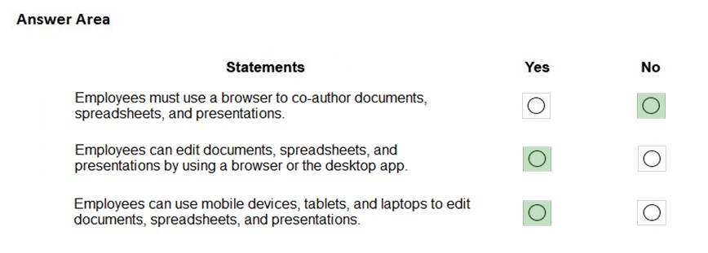

You need to determine the cause of the error message.

What is the cause?

* +  The user account is not a member of the global admin role
  +  The company does not have Premier support.
  +  The user does not have a license assigned for the app.
  +  The user account is disabled.

49. Question

You are an IT Administrator for a  large company with Office 365 global admin account. You need to follow one of the following concepts to decide when users will get a Windows release. Please choose the best answer.

* +  Windows Insiders
  +  Service channel
  +  Deployment ring
  +  Service Branch

50. Question

You are in Microsoft 365 administrator for a company stop user experience is an issue with SharePoint online you need to resolve the issue which two options can you use?  
Note that each correct answer presents a complete solution.

* +  create a service request from SharePoint portal
  +  create a new service request from Microsoft 365 admin center
  +  go to the SharePoint admin center and create a support request
  +  contact Microsoft Technical Support by telephone

51. Question

.The company plans to purchase Microsoft 365 enterprise licenses which two options can you use.  
Each correct answer represents a complete solution.

* +  with an enterprise agreement subscription from Microsoft
  +  from the Microsoft retail store
  +  from the Microsoft website using it corporate credit card
  +  from some company which is a cloud solution provider CSP

52. Question

Which Microsoft 365 feature utilizes biometrics?

* +  Windows Information Protection
  +  Windows Defender ATP
  +  Windows Hello for Business
  +  Windows advanced biometric scanner
  +  AIP

53. Question

Let’s assume that you have been hired by ABC company as a security administrator for their Microsoft 365 environment. You have been advised to ensure that employees accessing the system from outside the corporate network must use corporate devices. Which tool could you use to meet this organizational requirement?

* +  MFA
  +  Conditional Access
  +  Access reviews
  +  On-Premise data gateway

54. Question

Exchange Online hybrid is an example of what kind of cloud deployment model?

* +  Service Cloud
  +  Public Cloud
  +  Private Cloud
  +  Hybrid Cloud

55. Question

Identify three core components of Microsoft 365?

* +  Enterprise Mobility+Security
  +  Office 365
  +  Windows 10 Enterprise edition
  +  Windows Server 2019
  +  Windows 10 Home edition
  +  Microsoft Azure Sentinel